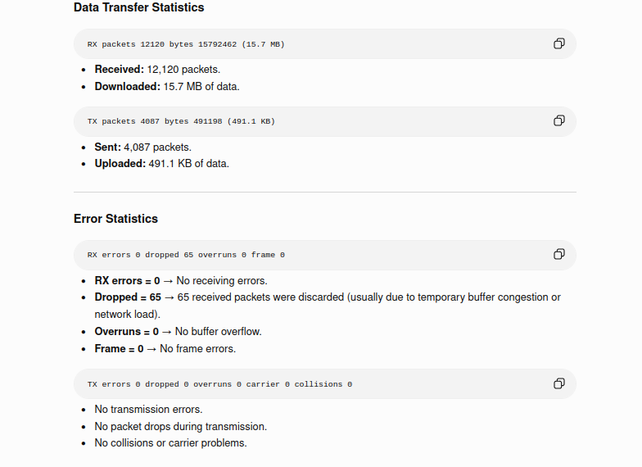

Ifplugstatus
whether ethernet cable is plugged in or not.

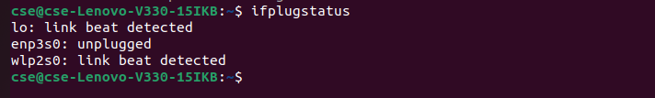

Iftop

ip a

The ip a command displays all network interfaces, their IP addresses, MAC addresses, and their current status.

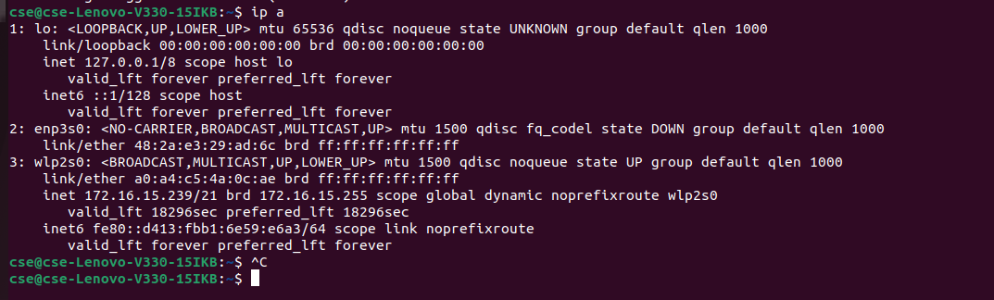

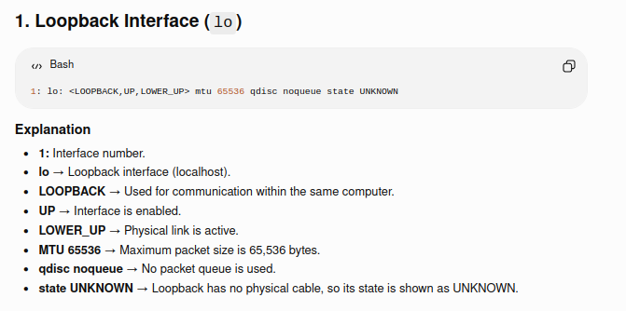

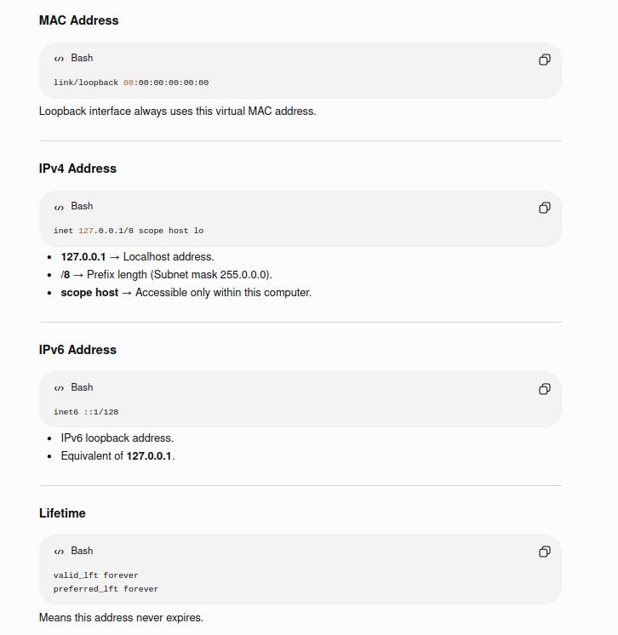

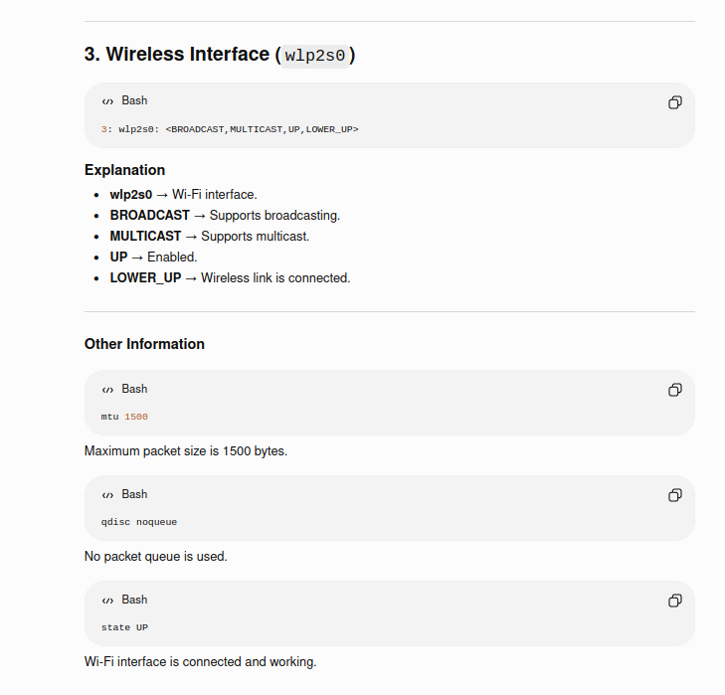

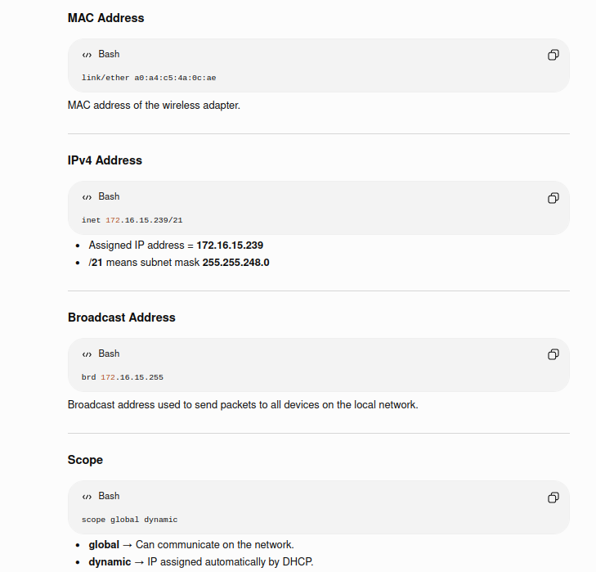

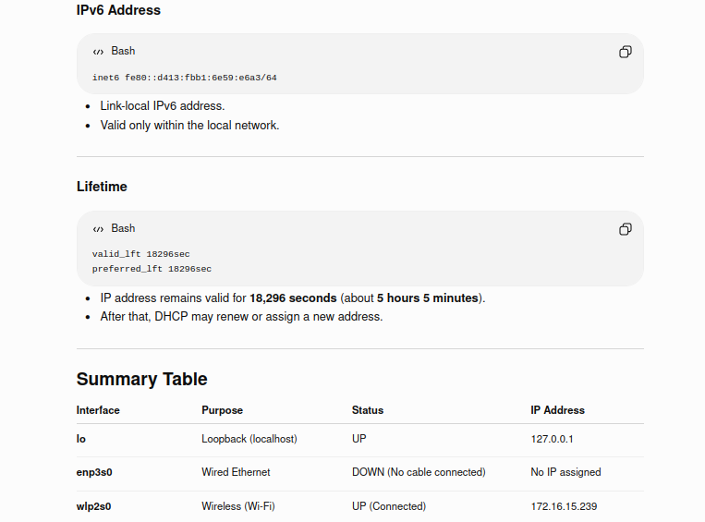

Nmcli

nmcli (Network Manager Command Line Interface) is a command-line tool used to manage network connections in Linux. It works with the NetworkManager service to configure wired, wireless, and VPN connections.

Purpose
- View network devices and connections.
- Connect to Wi-Fi networks.
- Enable or disable network interfaces.
- Configure IP addresses (DHCP or Static).
- Troubleshoot network connectivity.

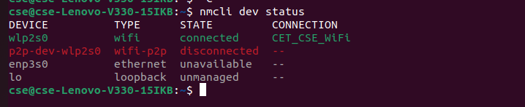

ping Command in Linux
The ping command is a network utility used to check whether another computer or website is reachable over a network. It also measures the time taken for data packets to travel from your computer to the destination and back.

Purpose
- Check if a host is reachable.
- Test Internet connectivity.
- Measure network response time (latency).
- Troubleshoot network problems.

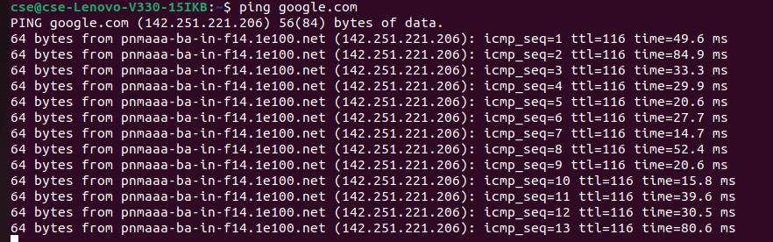

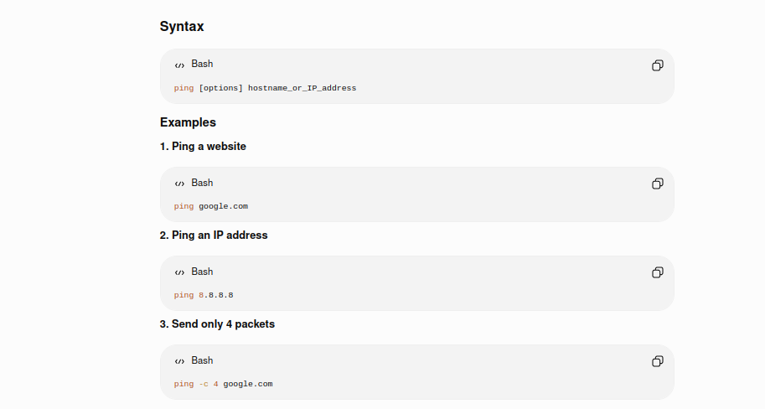

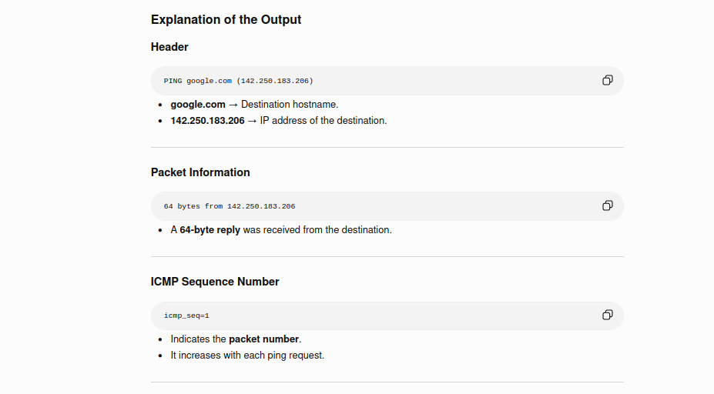

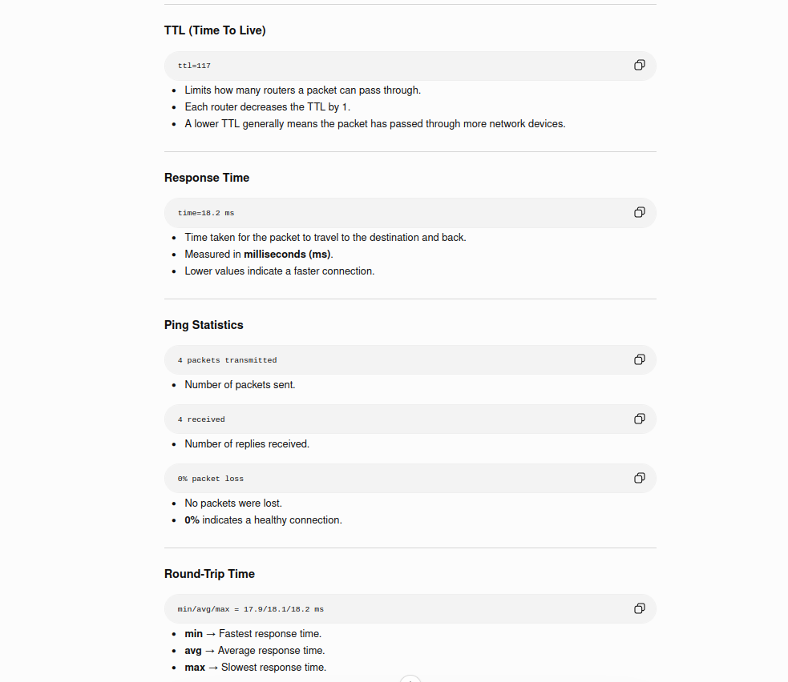

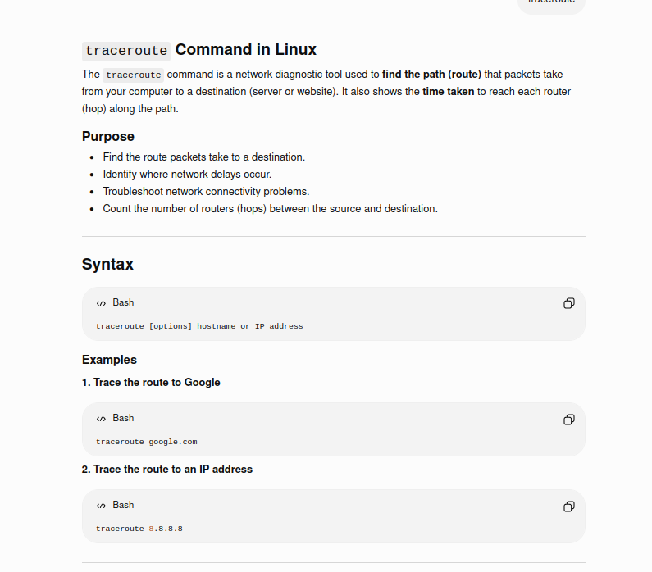

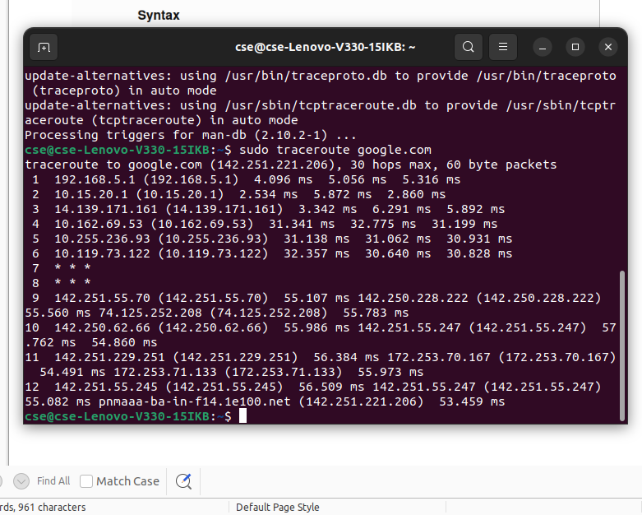

mtr Command in Linux
mtr (My Traceroute) is a network diagnostic tool that combines the features of ping and traceroute.
- ping tells you if a host is reachable and measures response time.
- traceroute shows the path packets take.
- mtr does both continuously, providing real-time statistics for each hop.



Type mtr in the terminal.

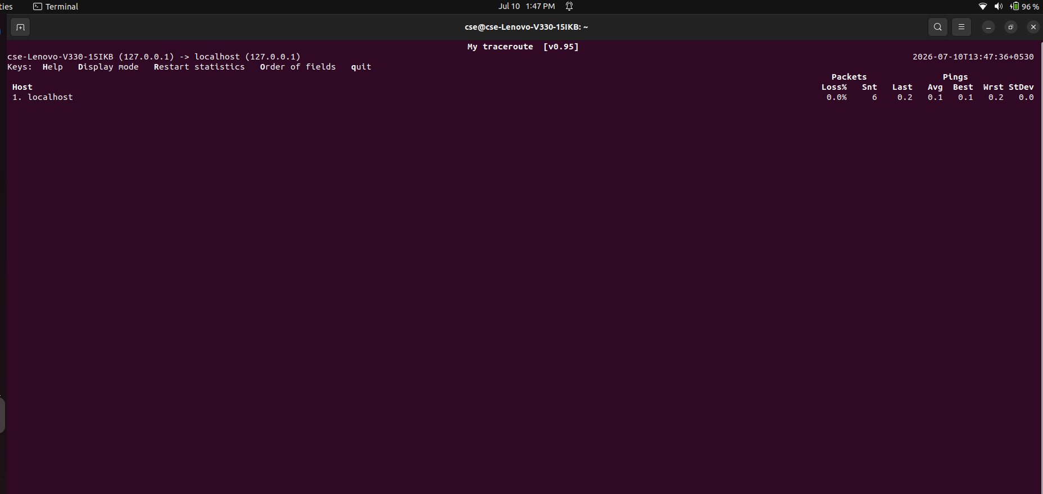

netstat (network statistics)
is a built-in command-line tool used across Windows, Linux, and macOS to monitor network activity. It displays active TCP/UDP connections, listening ports, routing tables, and interface statistics. It helps diagnose connectivity issues and identify unauthorized services.

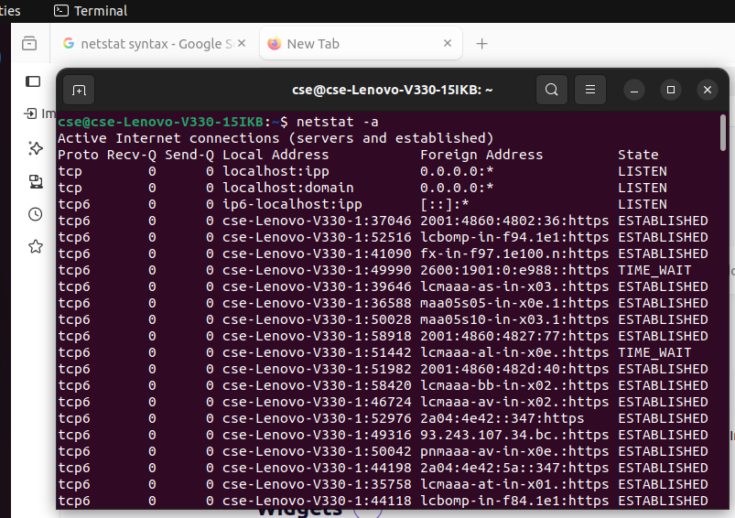

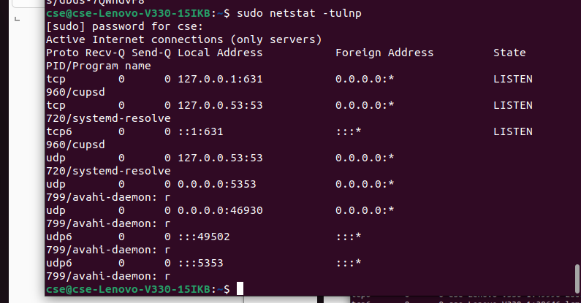

Netstat tulnp is commonly used to display all listening TCP and UDP ports along with the process using each port.

Option | Meaning
-t | Show TCP connections.
-u | Show UDP connections.
-l | Show listening (server) sockets only.
-n | Display numeric IP addresses and port numbers.
-p | Show the PID and program name using the port (requires sudo on most systems).

Whois

The whois command in Linux is a command-line client used to query remote databases for ownership, registration, and technical details of internet resources like domain names, IP addresses, and Autonomous System Numbers (ASNs).

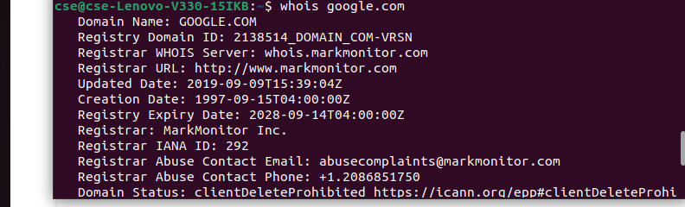

Iftop and bmon

iftop and bmon are powerful, lightweight, command-line network monitoring tools for Linux. iftop acts like the top command for network connections—showing active hosts and bandwidth consumption in real-time. bmon is a broader bandwidth monitor that visualizes overall network interface traffic and rates.

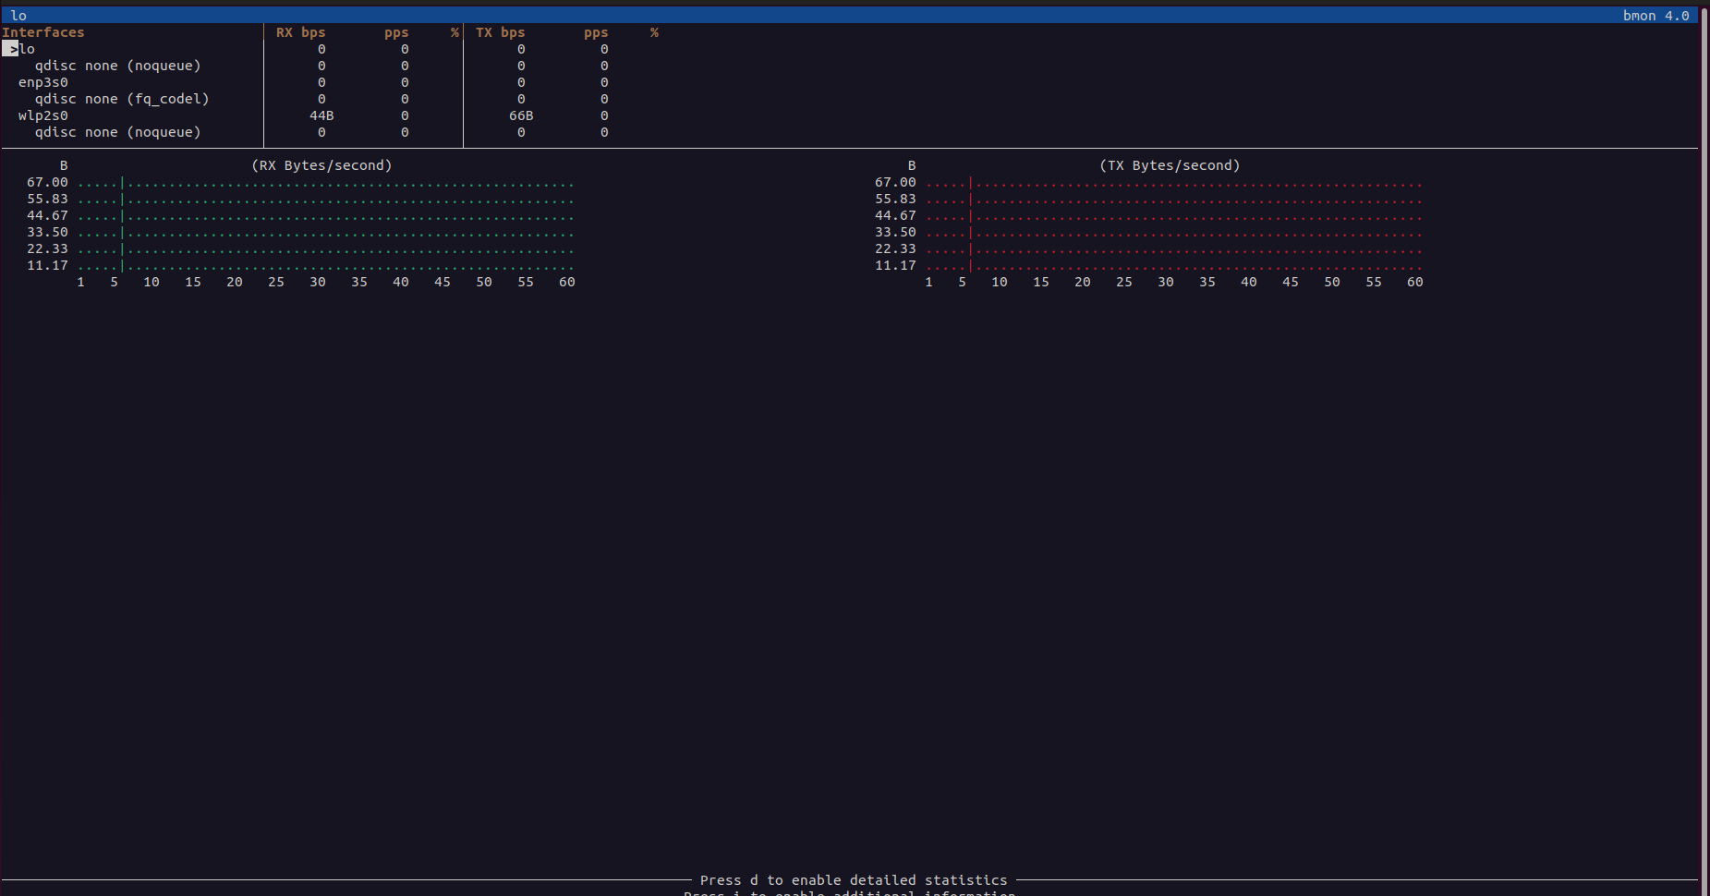
Bmon output

Nmap (Network Mapper) is a free, open-source utility for network discovery and security auditing. Systems administrators and security professionals use it to scan networks, identify live hosts, discover open ports, detect running services, and fingerprint operating systems.

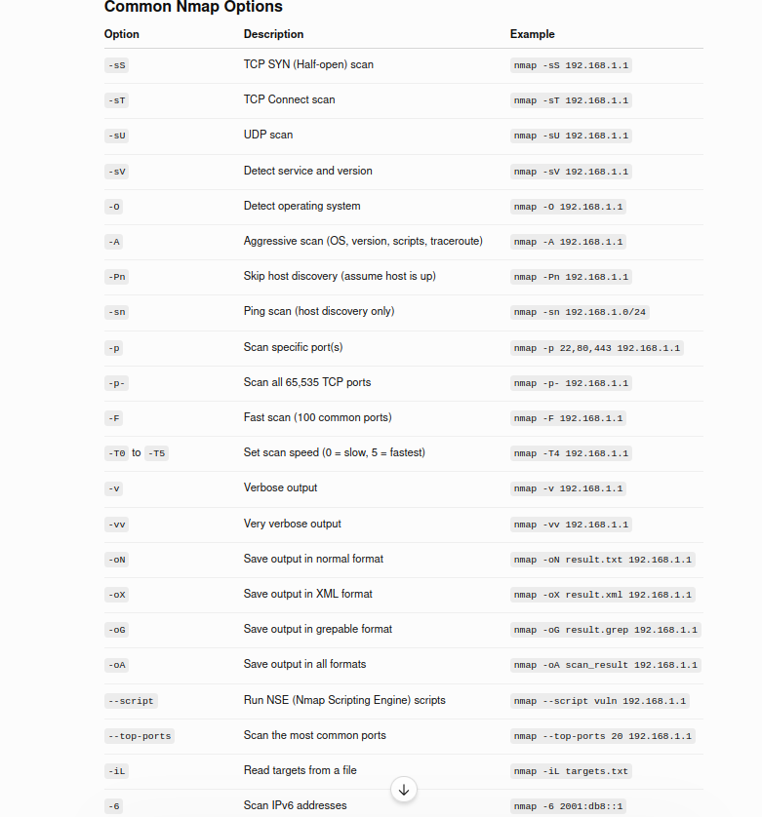

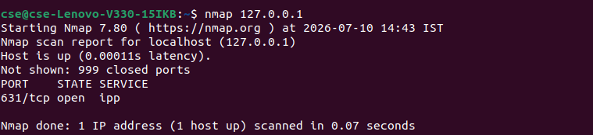

nslookup

nslookup (from name server lookup) is a network administration command-line tool for querying the Domain Name System (DNS) to obtain the mapping between domain name and IP address, or other DNS records.

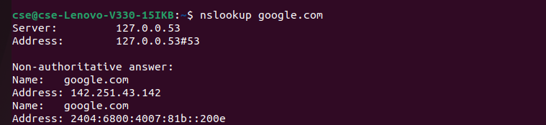

TCPdump is a powerful command-line packet analyzer for Linux and Unix-like systems. It allows you to capture, decode, and save network traffic in real time. Network administrators and security professionals use it for troubleshooting bottlenecks, detecting malicious activity, and debugging service issues.

Essential Options (Flags)
- -i [interface]: Specifies the network interface (e.g., -i eth0 or -i any).
- -n: Shows numerical IP addresses instead of resolving domain names.
- -nn: Disables both domain name and port name resolution (e.g., shows 80 instead of http).
- -c [count]: Stops the capture automatically after a set number of packets.
- -v / -vv: Increases output detail (verbosity).
- -A: Prints packet contents in readable ASCII text.
- -X: Prints packet contents in both Hexadecimal and ASCII formats.
- -w [file.pcap]: Saves the raw packets directly to a file for tools like Wireshark.
- -r [file.pcap]: Reads and filters packets from a saved file instead of live traffic.

